Endless Zombie Game

By Trung Le (Kyle Hunter)

# Concept (who, what, when, where, why, how)

Endless horde zombie survival game. A techno virus is infecting the galaxy, causing the robotic workforce to malfunction and become hostile towards anything non-infected. As a member of the galactic special force, you are tasked with controlling the spread of the virus and authorized to use lethal force.

# Objective:

The player must survive for the duration of the timed level by fending off the impending horde of mechanical zombies.

# Core System

* 2 main scenes: StartScene and GameplayScene
* Industry-standard Third Person Shooter:

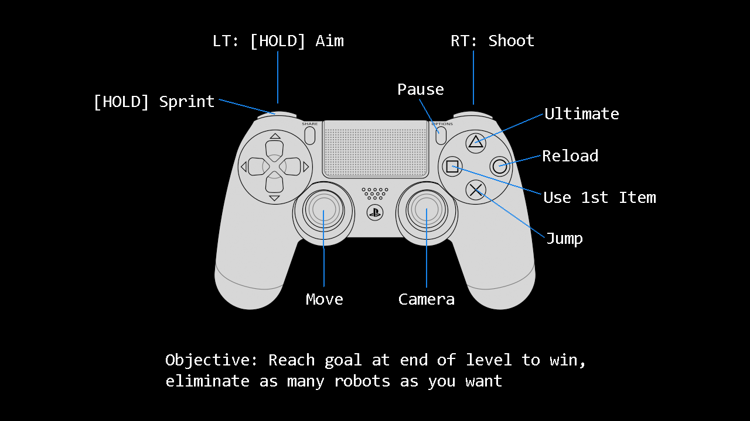

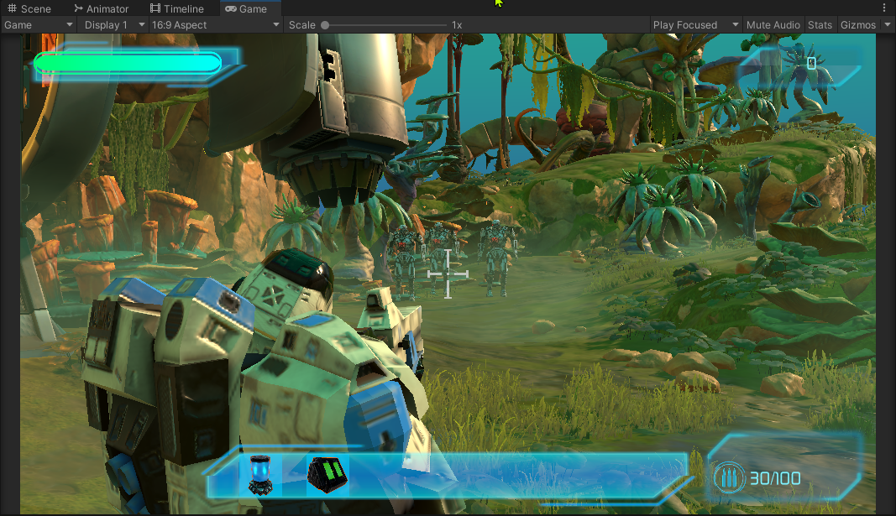

* Double Jump

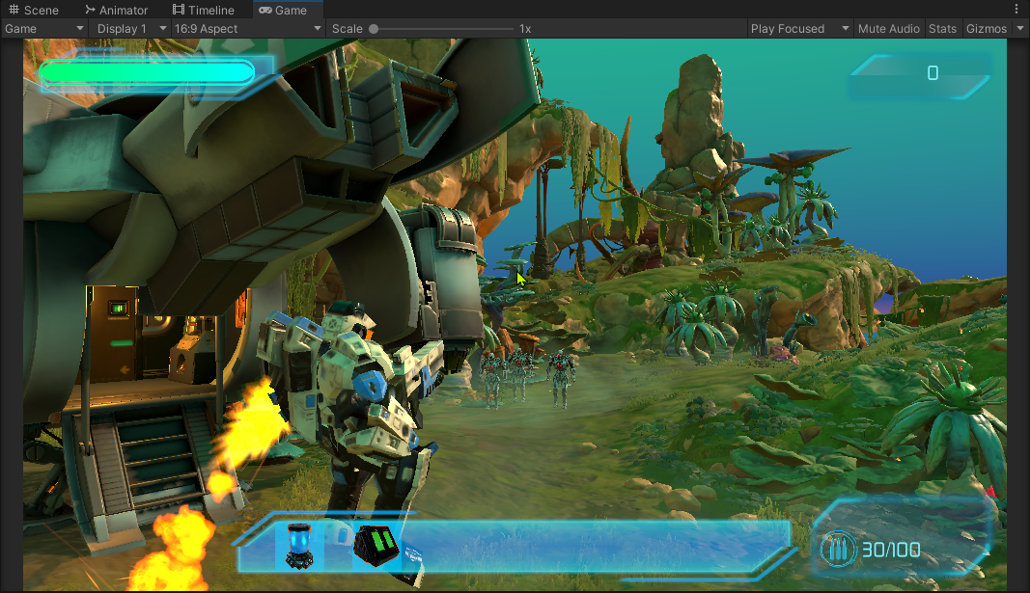

* Ultimate ability:

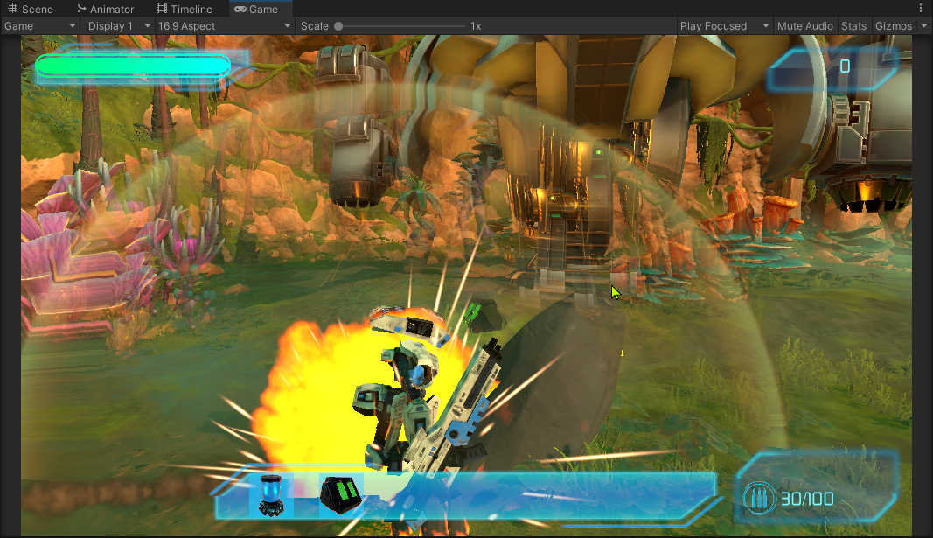

* Ragdoll physics:

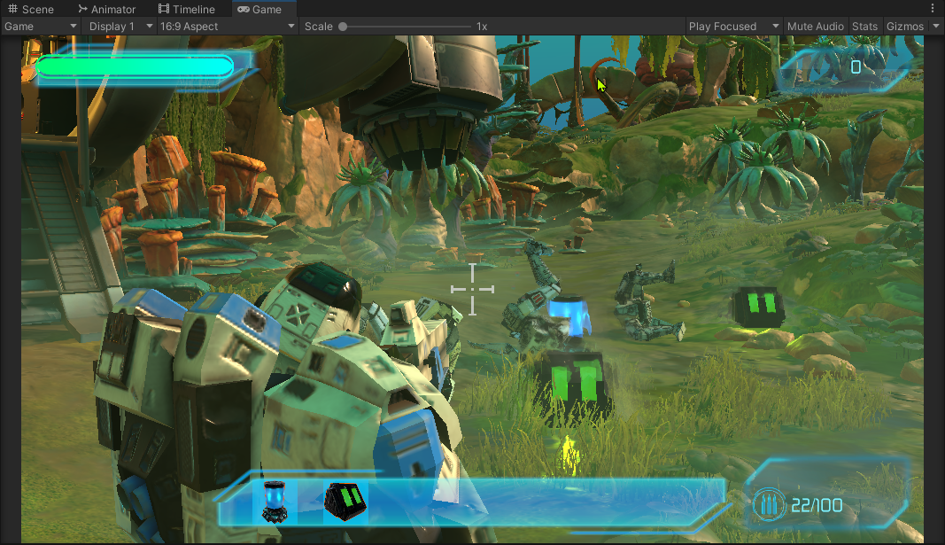

* Enemies
  + Standard Robot: will either chase or shoot you

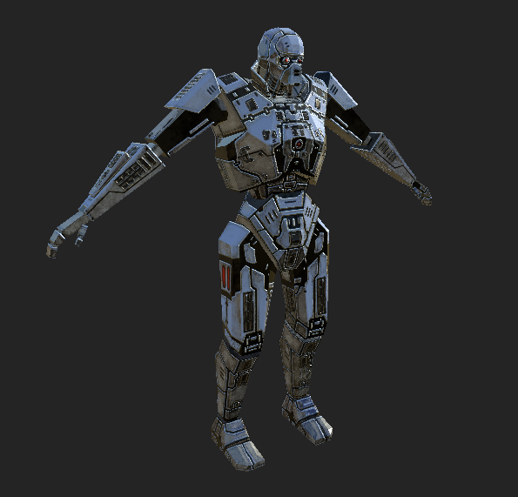

* + Will drop potion or ammo when dead:



* + Will be spawned randomly in level and will chase you:

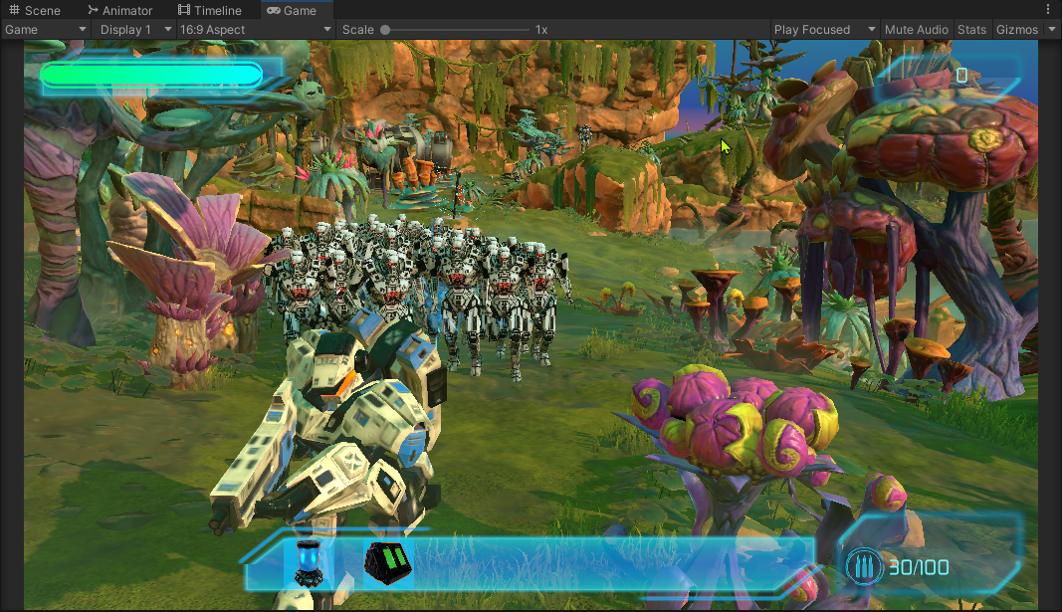

* Damage: Shoot or use ultimate ability to damage enemies.
* Killcount: killcount increases when enemy despawns.

# Supporting System

* Inventory: The player can pick up potion and ammo, then press a button to use the 1st one as a consumable. HP or ammo will be restored to max. If you have more than 7 items then the pickup will be destroyed.

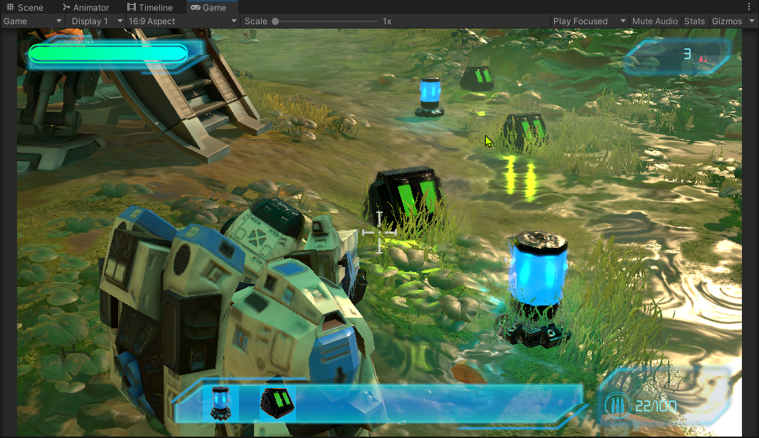

# Save System

What will be saved:

* Equipped weapon/ammo
* Current health
* Current player position
* Current kill count

# Menu

* Main Menu
* Tutorial screen
* Pause menu
* Game Over screen

# Sounds

* Randomized sounds for various effects

# Effects

* Almost everywhere.